**Họ tên:** Nguyễn Phạm Ngọc Duy

**MSSV:** 20133031

**HADOOP STREAMING**

1. **Install Python**

# apt update

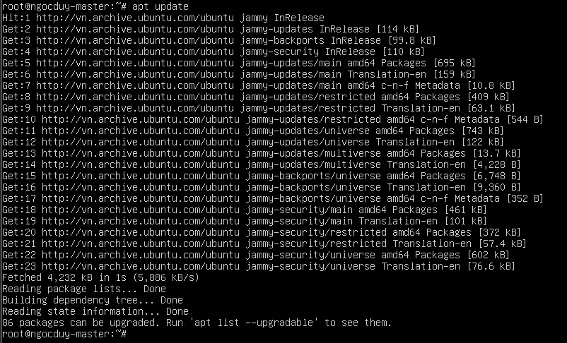

# apt install python-is-python3

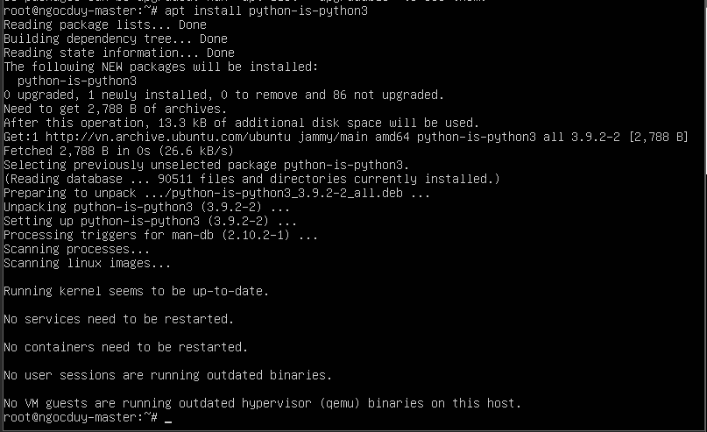

# whereis python3



1. **Example Using Python**
   1. **Mapper Phase Code**

File mapper.py, chmod -R 777 mapper.py

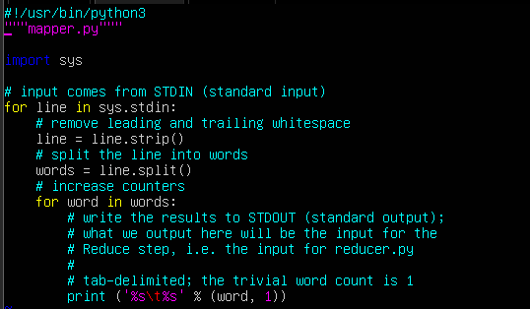

* 1. **Reducer Phase Code**

File reducer.py, chmod +x reducer.py

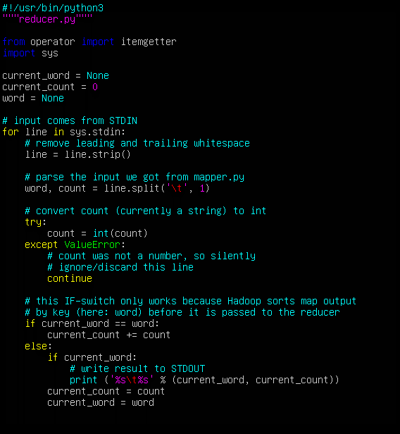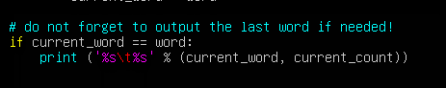

1. **Execution of WordCount Program**

* Tạo folder my_input và đặt file1.txt vào folder

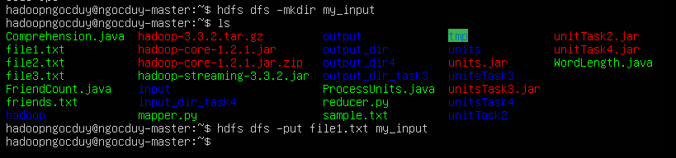

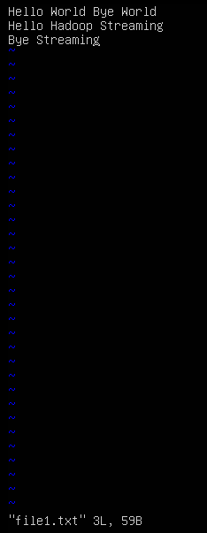

$ hadoop jar hadoop-streaming-3.3.2.jar -input my_input -output my_output_5 -file /home/hadoopngocduy/mapper.py -mapper ~/mapper.py -file home/hadoopngocduy/reducer.py -reducer ~/reducer.py

